2

Analyses of Bars and Trusses

Exercise 1

* Create the bar’s skeletal model

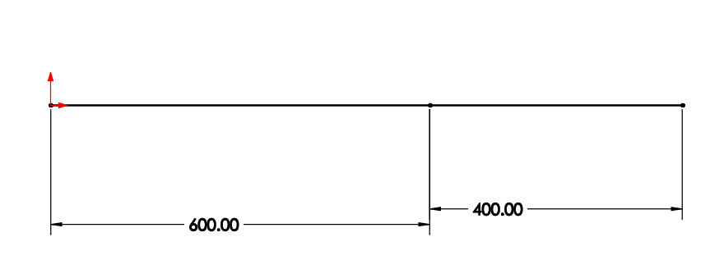

* Create the weldment profile

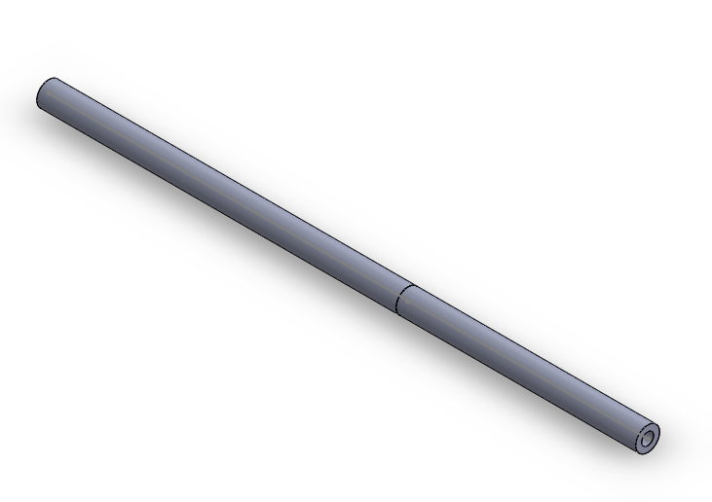

* Complete the simulation study
  + Apply material (Alloy Steel)
  + Apply constraint (A fix support at joint A)
  + Apply force
  + Run the study to get the solutions/results

**Maximum displacement of end C**

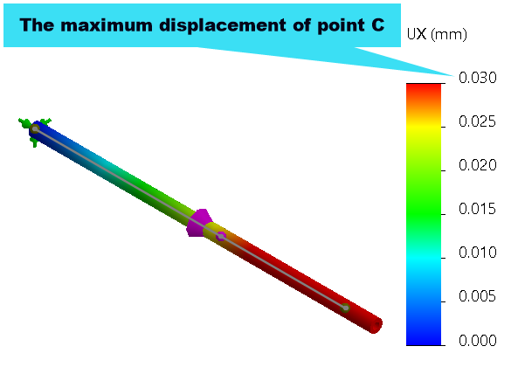

**Stresses:**

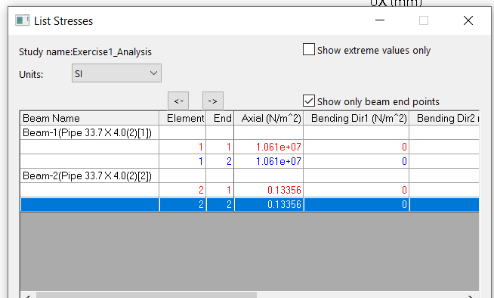

**NOTE:**

Note, when you open the SOLIDWORKS simulation file, you will notice that the results are greyed out. Re-run the analysis as indicated below to re-compile the results.

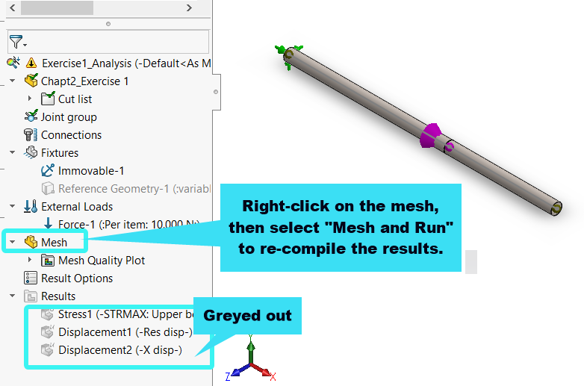

Exercise 2

* Create the truss’s skeletal model

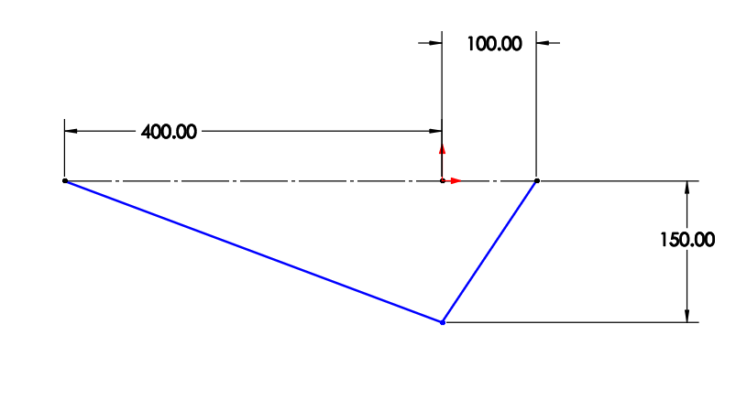

* Generate the weldment profile

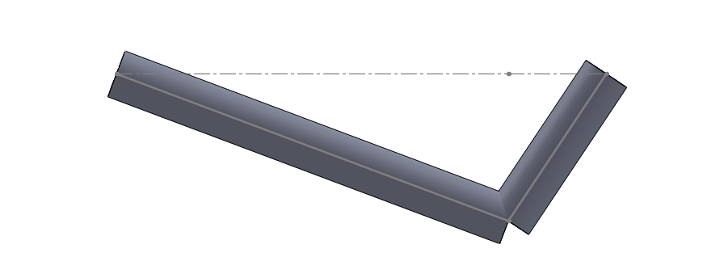

* Create the simulation set-up
  + Apply material, fixture, and loads
    - Apply $25 kN$ at B
    - Apply fixed support condition at point A and C

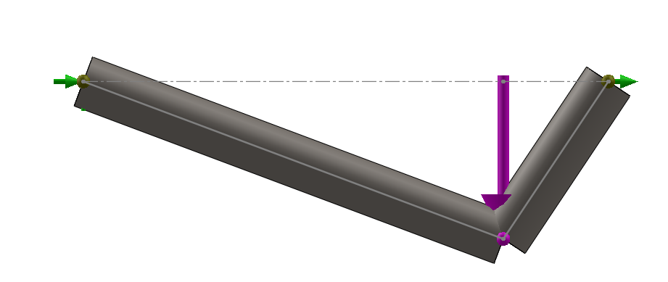

* Complete the solution
  + **Resultant displacement of joint B**

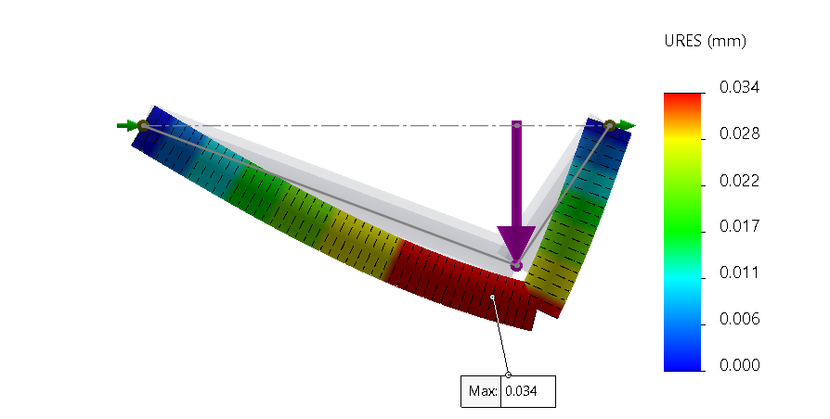

* + **Minimum factor of safety of the assembly**

